Att 直播接口内容。。。创建房间 关闭直播 直播信息

class Model_Live extends PhalApi_Model_NotORM {

    /* 创建房间 */

    public function createRoom($uid,$data) {

Line4

Line 150

    /* 关播 */

    public function stopRoom($uid,$stream) {

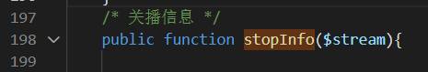

<http://www.yb080.cc/appapi/Live.stopInfo&stream=44239_1637315644>

http://www.yb080.cc/appapi/Live.stopInfo&stream=44239_1637315644